Notes on temperature change due to climate change and mortality

GHHIN Concept notes:

‘The Intergovernmental Panel on Climate Change projects the observed trends of heat
waves lasting longer, occurring more frequently, occurring earlier in the year, and at increasingly higher than normal temperatures in many parts of the world will continue with high confidence into the future.’

Ahmedabad heat action plan 2016:

‘Climate change is leading to an increase in average temperatures and increased possibilities of severe heat waves. Extreme heat can lead to dangerous, even deadly, health consequences, including heat stress and heatstroke’

IPCC: impacts, adaptation and vulnerability

(pg. 13)
‘The key risks that follow, all of which are identified with high confidence, span sectors and regions. Each of these key risks contributes to one or more RFCs:
…
Risk of mortality and morbidity during periods of extreme heat, particularly for vulnerable urban populations and those working outdoors in urban or rural areas
…

(pg. 19)
Human health
Until mid-century, projected climate change will impact human health mainly by exacerbating health problems that already exist (very high confidence)
Examples include greater likelihood of injury, disease, and death due to more intense heat waves and fires (very high confidence);

(pg. 23)
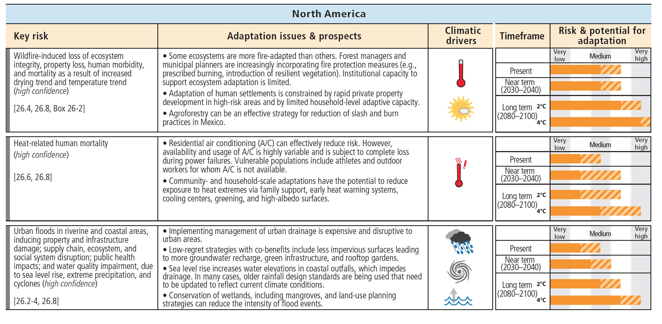

Lancet Countdown

WHO estimated that, in 2012, 12·6 million deaths (23% of all deaths worldwide) were attributable to modifiable environmental factors, many of which could be influenced by climate change or are related to the driving forces of climate change.

The 2009 UCL–Lancet Commission: managing the health effects of climate change described the ways in which climate change acts as a force multiplier for threats to global health.

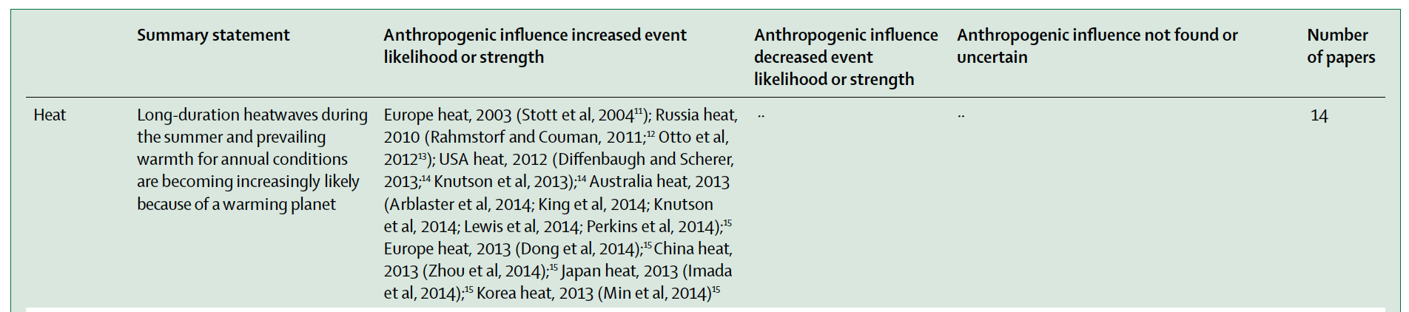

EURO-CORDEX: new high-resolution climate change projections for European impact research

For the analysis of the change in number of heat waves, we used two different definitions. In the first definition, heat waves were considered as periods of more than three consecutive days exceeding the 99th percentile of

the daily maximum temperature of the May to September season of the control period (1971–2000). The second definition, representing more extreme heat wave events, is based on the WMO definition (Frich et al. 2002). Heat waves were defined as periods of more than 5 consecutive days with daily maximum temperature exceeding the mean maximum temperature

of the May to September season for the control period (1971–2000) by at least 5 C.

Quantifying the influence of global warming on unprecedented extreme climate events

We find that historical global warming has increased the severity and probability of the hottest monthly and daily events at more than 80% of the observed area

